**React**

**Day 15th**

**React Elements**

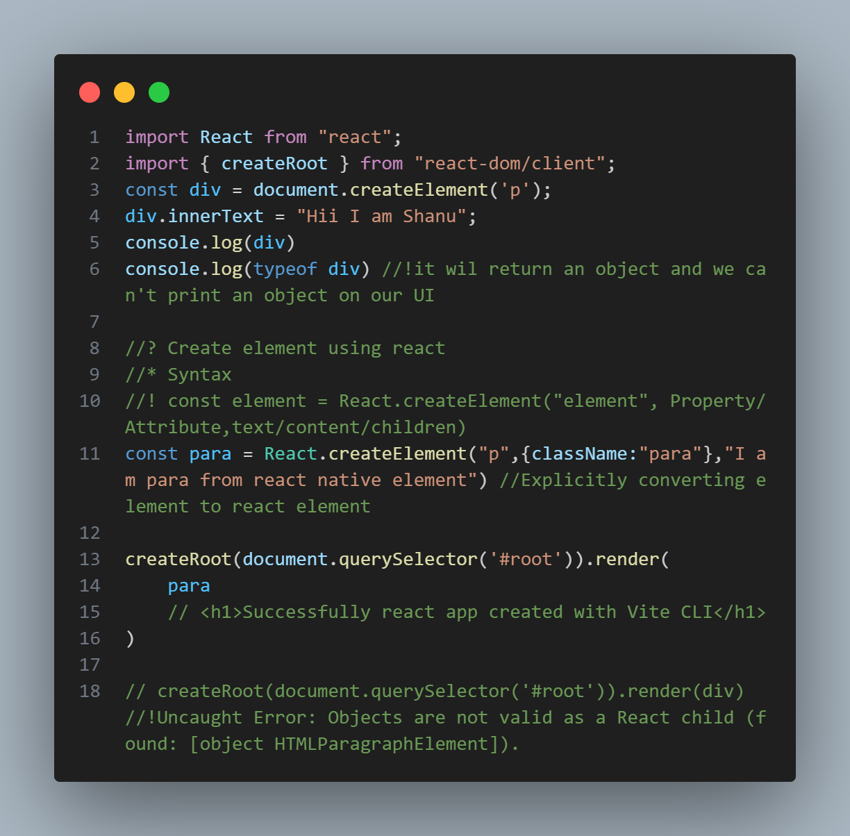React library returns an object having some properties and methods.

Here we have two kinds of code in this picture.

1. First I have created using React.createElement(‘element name’, ‘attributes’, ‘children/text’)
2. The second one in which I have used JSX. Means first create an HTML like element and store it inside a variable and use it.

**Create element in React**

CreateElement lets you create a react element. It serves as an alternative to writing JSX.